Lượm lặt từ ENCODE-DREAM in vivo Transcription Factor Binding Site Prediction Challenge

- The ChIP-seq data does not inform directly which strand the binding site is on.
- 3 papers from the challenge:
- https://genome.cshlp.org/content/early/2018/12/19/gr.237156.118: Anchor: Trans-cell type prediction of transcription factor binding sites
- https://www.ncbi.nlm.nih.gov/pmc/articles/PMC6327544: Accurate prediction of cell type-specific transcription factor binding
- https://www.sciencedirect.com/science/article/pii/S1046202318303293?via%3Dihub: FactorNet: A deep learning framework for predicting cell type specific transcription factor binding from nucleotide-resolution sequential data
- Transcription là có hướng, vì vậy khi vẽ TSS người ta thường vẽ thêm mũi tên
-Tìm hiểu DNase-seq ở đây: https://www.youtube.com/watch?v=U5qW8s7sFHE
+Trong DNase-seq results: peaks correspond to regions where DNaseI digest the DNA and were identified by sequencing.
+Nucleosomes at the beginning of each gene are strongly acetylated perhaps making them easier to move by chromatin remodeling proteins in the transcription apparatus

-Cis vs Trans Regulation

Why this Challenge?
- While the number of in vivo TF-binding datasets continue to grow, it is still not possible to perform TF ChIP-seq assays for every expressed TF against all cell types/tissues under all possible physiological conditions. Hence, accurate and high-resolution computational approaches are necessary to close this gap and complement experimental results.

Input data: DNA sequence + Dnase-seq + RNA-seq, evaluate on chIP-seq
-Sequence, but not enough to accurately predict context-specific TF binding maps as they fail to model several context-specific factors beyond the intrinsic DNA sequence affinity of the TF and the local sequence context such as TF concentration, cooperation and competition with other Tfs and nucleosomes, local chromatin state and distal regulatory interactions
-DNase-seq assay was developed to obtain genome-wide maps of chromatin accessibility
-New computational approaches that integrate DNA sequence with chromatin accessibility data are now capable of predicting context-specific TF-DNA binding maps. However, differences in data processing, selection of negative background and evaluation measures have confounded performance comparison of these methods.

Evaluation
Cross-tissue predictions
Within-tissue predictions

ENCODE project
-Has generated a large collection of Dnaseseq, RNA-seq, chIP-seq in a variety of cellular contexts

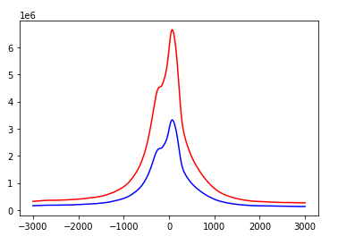

or this profiles of cell populationpopulation?
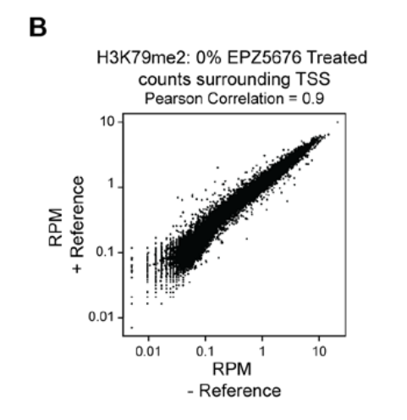

Scatterplot of RPM densities for a region -5kb/+10kb around each TSS for H3K79me2 samples not treated with EPZ5676 that included drosophila S2 reference cells (y-axis) or did not (x-axis).

Đọc lại bài báo kinh điển nhất về chIP-seq normalization

- Generally, biological replicates are defined as measurements of biologically distinct samples that show biological variation. In contrast, technical replicates are repeated measurements of the same sample that show independent measures of the noise associated with the equipment and the protocol

- RPKM normalization

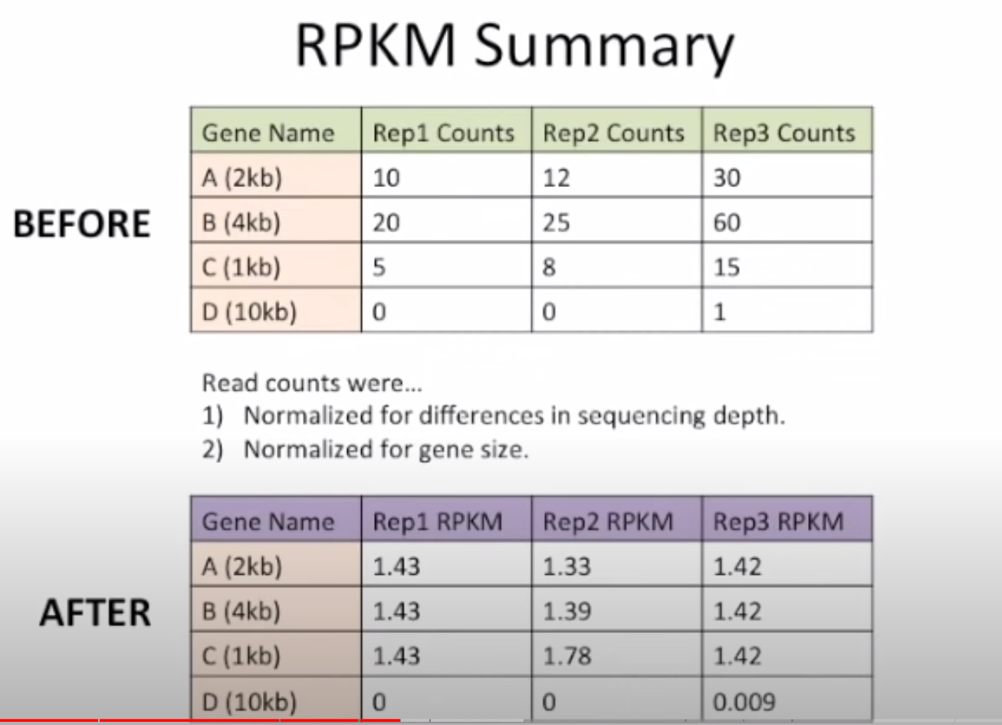

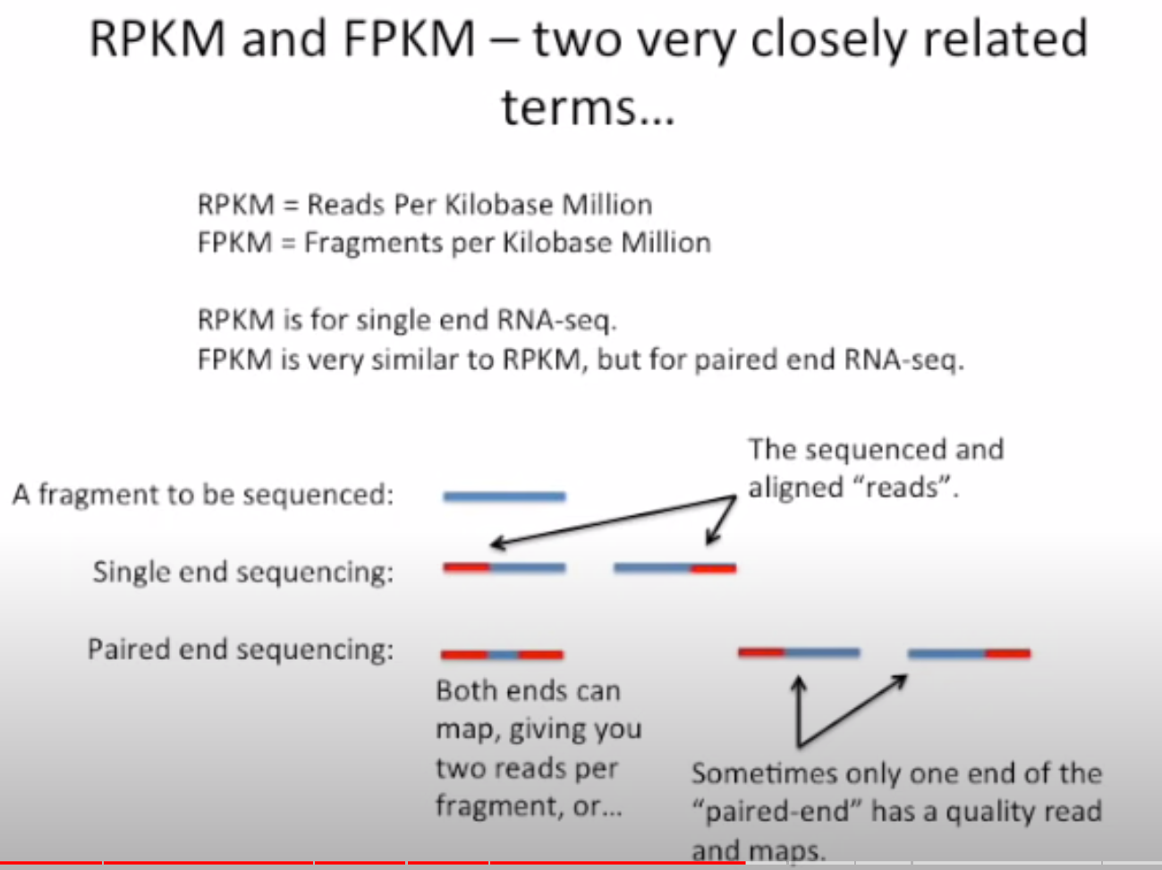

All FPKM does is to keeps track of the fragments so that one with two reads is not counted twice

